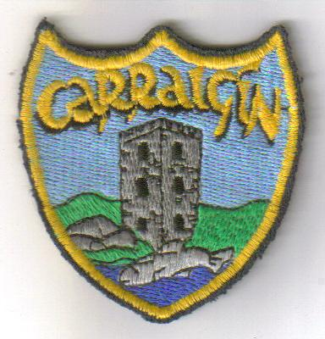
School Uniform Policy

It is important that our pupils learn to present themselves appropriately. A neat and tidy school uniform helps our pupils to understand the importance of presentation and helps them develop their self-esteem and self-confidence. Carrigeen NS endeavours to maintain the highest of standards in matters of dress code and personal appearance for all pupils in the school and it is expected at all times as it represents the standards set by our school for our pupils.

Pupils’ Appearance:
Parents should ensure that pupils comply with these standards in matters of general appearance and dress. The school uniform is to be worn by pupils on all school days unless parents are notified in advance of a change. On P.E. days/match days/swimming etc... pupils should wear the school tracksuit.

It is understandable that from time to time a child may come to school without the correct uniform due to unforeseen circumstances. In this case, the child should bring a written note to school explaining the reason for not having the correct uniform.

School Uniform:

SCHOOL UNIFORM BOYS- Navy pants, Sky blue shirt, Navy Jumper(HIGH V-NECK),
SCHOOL UNIFORM GIRLS- Navy skirt/Pinafore/Pants, Sky blue shirt, Navy Jumper(HIGH V-NECK), Cardigan, Navy Tights or navy socks,

FOOTWEAR- BLACK OR NAVY SHOES ON UNIFORM DAY
RUNNERS ON TRACKSUIT DAYS ONLY.
TRACKSUIT- The school tracksuit can be purchased from K-SPORT. A plain (non-crested), sky blue polo shirt may be worn under the tracksuit top.

Other Considerations:
- Please ensure that all uniform items are clearly labelled with your child’s name.
- In Summer, plain navy short pants may be worn.
- Ties are not to be worn in school. They will be supplied by the school for special occasions like Confirmation/School photographs etc.

This policy was ratified by the Board of Management on 10th May, 2016.

