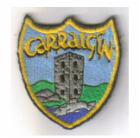

Carrigeen NS

Carrigeen,

Co.Kilkenny.

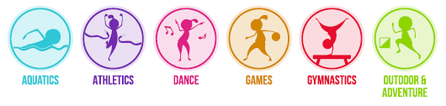

Physical Education (PE) Plan

Physical Education Plan – Carrigeen National School

Introductory Statement
This PE plan for Carrigeen NS was formulated in consultation with the teachers and members of the Board of Management with the support of an Advisor for Physical Education from the Professional Development Service for Teachers.

Rationale
Physical Education provides children with learning opportunities through the medium of movement and contributes to their overall development by helping them to lead full, active and healthy lives. We aim to provide optimum learning opportunities for the children in our school by maximising active learning experiences and approaches which benefit each individual child.

Vision
Physical Education is distinguished from other curricular areas by its primary focus on the body and on physical experience and is an integral part of the educational process, without which the education of the child is incomplete. In Carrigeen NS, by implementing a diverse range of experiences that provide regular, challenging physical activity, the balanced and harmonious development and general well-being of every child can be fostered.

Through our physical education programme, our children can experience the joy of physical exertion and the satisfaction of achievement while developing skills and positive attitudes that enhance self-esteem. Physical education provides opportunities to develop desirable personal and social attributes: the concept of fair play, the acceptance of success and failure, and the ability to co-operate in group situations. These opportunities contribute to the understanding and promotion of a healthy life-style. Physical education, as an integral part of the total curriculum, provides vital opportunities for the physical, social, emotional and intellectual development of the children in our school.

We aim to provide Physical Education opportunities which meet the physical needs of each child and their need for movement experiences, challenges and play. We aim to develop a desire for daily physical activity in all of the children through encouraging constructive and active use of free time, so that children will be motivated towards participation in physical activities in adult life. To fulfil these needs, our Physical Education programme is built on the principles of variety and diversity. We aim to provide a wide variety of movement activities appropriate to the level of development of each individual child.

Aims
We endorse the aims of the Primary School Curriculum for Physical Education
- To promote the physical, social, emotional and intellectual development of the child
- To develop positive personal qualities
- To help in the acquisition of an appropriate range of movement skills in a variety of contexts
- To promote understanding and knowledge of the various aspects of movement
- To develop an appreciation of movement and the use of the body as an instrument of expression and creativity
- To promote enjoyment of, and positive attitudes towards, physical activity and its contribution to lifelong health-related fitness, thus preparing the child for the active and purposeful use of leisure time.

Objectives of Physical Education
The broad objectives of the PE curriculum have been considered in the design of this plan:

Social and personal development
- experience enjoyment and achievement through movement
- interact and co-operate sensitively with others, regardless of cultural or social background or special needs
- develop qualities of self-esteem, self-awareness, confidence, initiative and leadership through movement
- develop an understanding of fair play and team spirit through participation and competition
- develop positive attitudes towards participation in movement activities
- experience adventure and challenge

Physical and motor development
- develop strength, speed, endurance and flexibility through engaging in a wide variety of activities
- develop agility, alertness, control, balance and co-ordination through movement
- develop personal competence in the athletic skills of running, jumping and throwing
- perform dances with confidence and competence, including simple folk and Irish dances
- develop personal competence in a range of gymnastic movements
- develop personal competence in the games skills of sending, receiving and travelling using a variety of equipment, and to apply these skills in games situations
- apply the skills needed to live and move with confidence in the environment
- build water confidence near, in, on and under water
- develop personal competence in a variety of strokes and water agility

Knowledge and understanding
- develop an understanding and general knowledge of movement activities and derive benefit as a participant and as a spectator
- develop an understanding of travel and weight-bearing as the basis of efficient body management and control, both on the floor and using apparatus
- experience and develop an understanding of the use of space, speed, effort, direction and level in the performance of actions
- develop an understanding of the appropriate basic rules, tactics and strategies of movement activities
- observe, discuss, analyse, interpret and enjoy the performance of movement
- gather, record and interpret information on achievement in movement activities
- be inventive, make decisions, solve problems and develop autonomy through movement activities
- participate in and develop a knowledge, understanding and appreciation of cultural activities through movement
- develop an appreciation of and respect for the environment through participation in activities outdoors

Creative and aesthetic development
- use the body as a means of expression and communication, using a range and variety of stimuli
- create and perform simple dances
- create and play simple games
- develop artistic and aesthetic understanding within and through movement

Development of health-related fitness
- maintain and enhance health-related fitness through vigorous physical activity that helps to promote a healthy life-style
- understand and practise good hygiene and posture
- appreciate the benefits of relaxation and cope with challenges

Development of safety
- adopt safe practices in all physical activities

We are particularly committed to inclusion and aim to meet the needs of children with disabilities and S.E.N.

Curriculum Planning for Physical Education

The PE curriculum is organised into the six strands shown above. These strands and strand units can be found on the following pages of the Physical Education Curriculum
- Infant classes pp. 16-23
- First and Second classes pp. 24-34
- Third and Fourth classes pp. 38-46
- Fifth and Sixth classes pp. 48-59
- Aquatics: Junior Infants-Sixth pp.62-64

In planning for teaching PE, teachers will be guided by the PE Curriculum Teacher Guidelines and will also use the PE lesson plans prepared by the Primary School Sports Initiative - PSSI Lesson Plans and the PDST Move Well, Move Often Physical Literacy Resource.

Developing the Physically Literate pupil in Physical Education

We use the Move Well, Move Often resource to support the teaching of Physical Literacy in Carrigeen NS. Physical literacy is the underlying goal of all physical activity. Physical literacy addresses the whole child and respects each pupil as an individual. The physically literate child can be described as having the motivation, confidence, movement competence, knowledge and understanding to value and take part in physical activity throughout their personal lifelong journey. Physical literacy includes four essential and interconnected elements whose relative importance may change throughout life: Movement Competence, Motivation and Confidence, Knowledge and Understanding, and Opportunities to engage in physical activity for life.

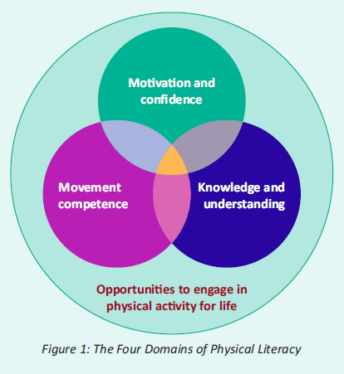

Physical Literacy gives pupils the tools they need to take part in physical activity and sport, both for healthy life-long enjoyment and for sporting success. To become physically literate, pupils need to master fundamental movement skills (FMS) through a series of developmental stages. FMS are the basic building blocks of movement and are an essential part of everyday life and recreational activity. It is only when these skills are mastered that a child can go on to develop specialised movement skills, which will allow them to reach their potential in sports-specific endeavours.

Fundamental Movement Skills

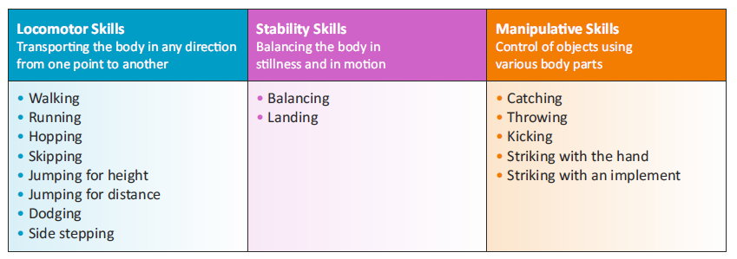

In Carrigeen NS, we recognise that it is important to teach a balanced range of locomotor, stability and manipulative skills across the strands during the year. Our whole school plan for PE reflects this approach. We are currently engaging with the PDST in-school support service in the area of Physical Literacy in developing a whole school approach to developing fundamental movement skills in physical education.

Resources for Teaching Physical Education

Teachers in Carrigeen NS will utilise the following core resources to support planning for and teaching a broad and balanced programme of Physical Education:

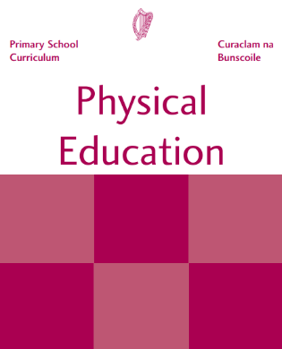 | 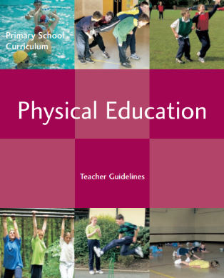 | 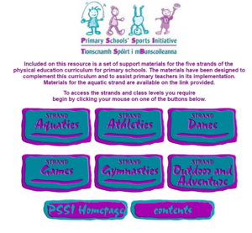 | 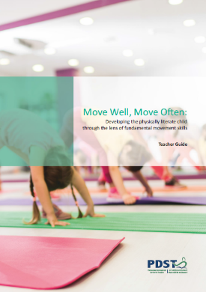
Physical Education Curriculum | Physical Education Curriculum Teacher Guidelines | PSSI Lesson Plans | Move Well, Move Often Physical Literacy Resource

The role of the teacher is to

Help each child to develop a positive self-image and sense of fair play and cooperate with others,

Ensure that the child experiences a variety of vigorous and challenging activities,

Foster a stimulating and secure environment in which the child can be creative and imaginative,

Link physical education activities with other curricular areas when appropriate,

Evaluate the programme and assess the progress of each child,

Provide information to parents, in line with school policy, about the class programme for physical education,

Have due regard for safety by ensuring that each child adopts safe practices.

Teachers will devise a balanced programme in line with this plan which meets the needs of each child in their class. Where possible, children will have experience the following five strands each year – Athletics, Dance, Gymnastics, Games, Outdoor and Adventure Activities.

Continuity and Progression

Teachers will ensure there is continuity and progression from class to class by
- Utilising appropriate warm-up activities relative to each class level.
- Following the structure of the PSSI lesson plans.

Recording the content covered at each level in each strand (Cúntas Míosúil)

Approaches and Methodologies
Teachers will use a combination of the following teaching approaches:
- Direct teaching approach
- Guided discovery approach
- Integration

Teachers will use methodologies that encourage maximum participation by the child such as individual, pair, group and team work, station teaching or using a play area divided into grids.

Children with Different Needs
In Carrigeen NS, we recognise that physical education is important in the curriculum for students with Special Educational Needs and disabilities. Pupils with special educational needs or disabilities depend on teachers to manage their learning and to provide support. In Carrigeen NS, inclusive PE ensures that all pupils experience a sense of belonging during the lesson. This includes feeling respected, valued for who you are, and feeling a level of supportive energy and commitment from others. It is important to create and encourage a positive environment and to provide pupils with opportunities to enjoy physical activity with others, so that they will, in the future, approach activity as a means of socialisation and integration in the community.

Many children with SEN experience difficulty with basic coordination, balance, left and right orientation, rhythm, and spatial and body awareness. These skills can be addressed and improved through physical education. As it is a practical subject, it is particularly suited to the learning styles of many students with general learning disabilities. Students who experience difficulties and frustration in academic areas of their school life can enjoy and acquire personal achievement and satisfaction in the physical education curriculum. Physical education is a student-centered curriculum that challenges each student at his/her personal level. It is also a very sociable subject involving a high level of appreciation and acceptance of others.

Physical education can enable students with general learning disabilities to acquire and enjoy many physical skills during their school life, and so widen the possibilities for recreation and socialization in their adult lives. It provides the student with an avenue to enjoy life and social interaction. All children will be encouraged to participate in all PE activities through the use of co-operative fun activities. We will provide encouragement and acknowledge good effort wherever possible. Our main aim is to set activities close to each child’s ability level but at the same time challenging them to improve their performance. Reasonable targets will be set for all children at individual, pair and small group levels. Teachers will endeavour to support and ensure the participation of children with Special Educational Needs and disabilities through an inclusive approach to planning for PE.

In order to make our PE curriculum inclusive and accessible, the following ideas may be considered when planning for inclusion of students with disabilities and Special Educational Needs:
- Skills, concepts and activities will need to be redefined and broken down into progressive stages to meet the varying abilities of these students.
- Learning expectations should be reasonable in meeting the balance between familiar and unfamiliar skills and activities.
- Realistic targets should be set, appropriate activities and equipment should be chosen, and sufficient time should be given to bridge the gap between applying familiar skills and learning and applying new skills and concepts.
- Positive reinforcement should be given frequently, the ability of the students should be emphasised, and appropriate activities should be provided in order to improve the self-esteem and confidence of these students.

The following support materials will assist teachers in planning for children with SEN and disabilities:

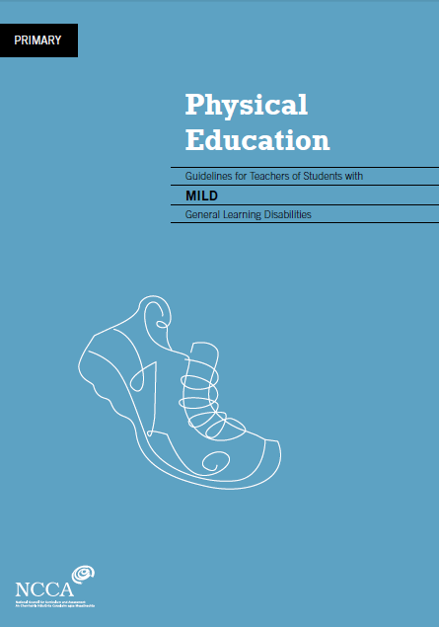 | 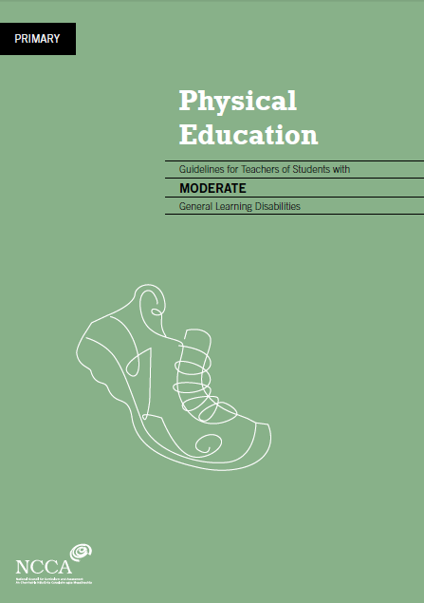 | 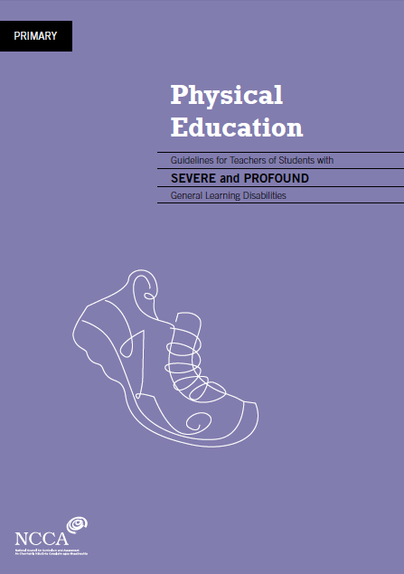 | 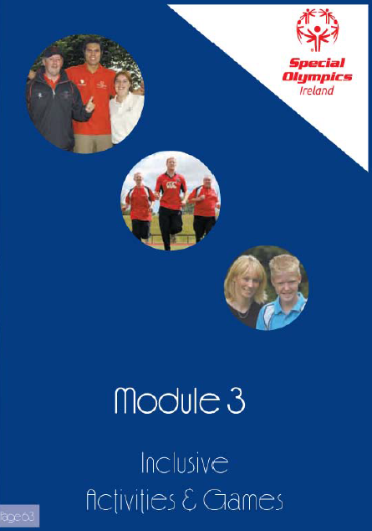 | 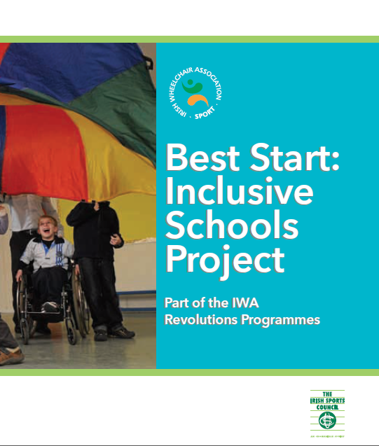
PE guidelines for teachers of children with Mild GLD | PE guidelines for teachers of children with Moderate GLD | PE guidelines for teachers of children with Severe and Profound GLD | Special Olympics PE teaching resources | Best Start: Inclusive Schools Project

All pupils exhibit a wide range of abilities in the area of PE. Some may be talented, some may be gifted, while others show significant needs and require guidance through a progressive and systematic approach to their participation and learning. In planning for teaching this subject area, it is important to keep in mind the following key issues and learning difficulties that pupils may have.

SAMPLE: POTENTIAL AREAS OF DIFFICULTY FOR STUDENTS WITH MILD GENERAL LEARNING DISABILITIES

Potential area of difficulty | Implications for learning | Possible  strategies
• fitness levels | It may be necessary to set targets to improve fitness. | • include active warm ups and drills for skills practice  • vary activities in the lesson to include the use of gross motor skills; regular short periods of exercise daily; cooling down exercises and consultation with parents/guardians
• listening and responding | The student may have difficulty with short–term memory and concentration span. | • keep instruction simple and clear. Students repeat instruction.  • demonstration(s) of task; verbal analysis of task; student performs task; teacher affirms task  • move to new instruction regularly
• co-ordination and balance | The student may have difficulties in fine and  gross motor skills in all strand areas. | • teach suitable gait for skill, for example, throwing and catching a ball, jumping and landing, balancing.  • give good visual demonstrations  • reaffirm good examples and practices  • use additional equipment to suit the needs of the student, for example softer balls, larger target  • provide physical support to student in performing skill, for example, jumping
• spatial and body awareness | There may be safety issues for students engaging in movement exercises. | • provide suitable group arrangements; restrict area of movement; plan for the student to engage in follow the leader, and copying and contrasting exercises  • use specific body parts in exercises e.g make a shape with the upper part of the body
• left–right orientation | It may be necessary to include regular exercises with these movements. | • include warm-up exercises/stretches. Students mirror actions of peers or teacher: O’Grady says; Follow the leader  • include exercises with equipment using both sides of the body
• behavior | This will necessitate the smooth  progression of lesson structure with clear instructions. | • establish routine format for class and the expectations of desired behaviours  • ensure that the student is suitably placed in the class for optimum learning  • check that the student is attending by reinforcing and questioning  • involve the student where possible in demonstration  • encourage the student and assign tasks opportunities for success
• social integration. | Keep appropriate balance between cooperative and competitive activities. Foster enjoyment of activities with others. Encourage individual student’s interest in particular aspects of the strands. | • group student(s) appropriately  • use co-operative fun activities regularly  • give encouragement and acknowledge good effort  • set appropriate skill development level commensurate with students’ ability level  • set reasonable targets for co-operative activities (individual and group).

Exceptionally Able Children

Children with exceptional ability or talent for PE will be encouraged and supported by acknowledging their talents and creating additional challenges for these children in the strands of the PE curriculum they excel in. These challenges will be based on the activity being pursued by the rest of the class. In addition, the children will be encouraged to maximise their talent by forging links with local clubs (if links have not been established already) so the child(ren) can progress their talent to a higher level. The children with exceptional ability will, on occasion, be encouraged to assist their classmates in achieving proficiency in the activities they are undertaking.

We will refer to the PE checklist in the NCCA Draft Guidelines for Exceptionally Able Students to identify children who have a special ability or talent for PE:

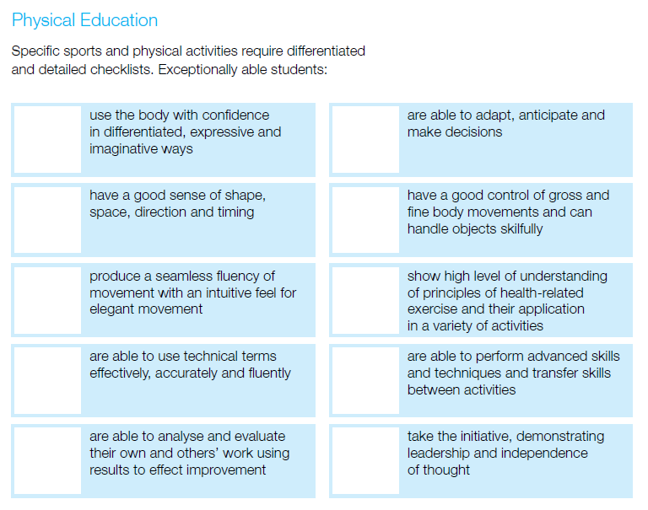

Assessment and Record Keeping

The teachers in the school constantly assess in the PE lessons delivered as we identify progress and difficulties.
We will assess
  - Willingness to participate in activities
  - Readiness to engage with a certain activity
  - The level of competence of a child in carrying out an activity
  - Interest in and attitude to activity
  - Willingness to cooperate in individual, pair and group activities

Our assessment tools are:
- Teacher observation
- Teacher-designed tasks

Assessment is used to provide information on individual children, assist the teacher in planning a programme and facilitates communication with other teachers, parents and other professionals.
- Assessment for learning to provide feedback to children, improve learning and inform practice
- Assessment of learning which helps to identify the milestones children reach and the progress they make to report to parents, other teachers and the children themselves.
- Assessment as learning involves teaching the children how to self assess and peer assess.

The assessment criteria used for each activity forms part of class and school planning.

Assessment information is shared with parents at Parent Teacher meetings and in end-of-year school reports. If concerns are noted during the year parents may be contacted. Information is shared between teachers during the year as need arises and in particular in the case of formulating Individual Education Plans.

Equality of Participation and Access

- We will endeavour to ensure that all children from infants to sixth class will partake in all six strands of the curriculum during their primary. We will provide equal access for all children to physical education equipment and facilities and the use of the playground during breaks will be incorporated as an integral part of the school’s programme.
- When grouping children for physical education the school will endeavour not to group children solely on the basis of gender whenever possible.
- As a staff we will help children to build positive attitudes towards all activities.
- We will take into account the needs of girls and boys when promoting the health related fitness of children.
- We will enter both boys and girls teams in inter-school competitions and where necessary (if we have insufficient numbers) we will take the opportunity to enter mixed teams.
- We will endeavour to celebrate multiculturalism through PE whenever possible, e.g. through including a variety of different types of Folk Dance or Games from other countries, from time to time.

Identify provision required, as and where necessary, for inclusion of children experiencing any form of disadvantage. Every child will have access to all PE activities provided by the school and lack of financial resources on behalf of the child will not hinder their participation.

Linkage and Integration

Many of the broad objectives of PE, such as the development of self-esteem, confidence, cooperation and spatial awareness, are shared with other curricular subjects. Within PE, it is through learning opportunities provided in the various aspects of movement that these objectives can be achieved. The transfer and reinforcement of learning from other areas of the curriculum can be achieved when PE is integrated with other subjects. This approach can be particularly effective in meeting the needs of pupils with individual and varied learning styles, and enables pupils to appreciate how physical literacy is an integral part of all our lives.

- Linkage can take place within the physical education curriculum, because many activities transcend strands and are of benefit to the child irrespective of the strands or subjects being covered. Within the content of the curriculum, footnotes below the strand units suggest where linkage and integration might take place in the PE class.

- Theme based activities will be used to support integration especially in the gymnastics strand where the language of movement can be developed in tandem with the practical activities under the theme of travelling. Further language development can take place under the theme of balance. Mathematical concepts in fifth and sixth class can be developed with the theme of symmetry and asymmetry in the PE class.

Language
The effective use of questioning from the teacher will develop the vocabulary associated with physical education. Allowing the children to analyse and describe their own performance will allow them understand and appreciate their learning in physical education.

Content and Language Integrated Learning (CLIL)
Content and language integrated learning (CLIL) is an approach to language learning where the target language is used as the medium to teach both content and language. This process enables the attainment of both content objectives and language objectives in the same lesson. CLIL is internationally recognised as a successful approach to language teaching and learning and offers a particularly favourable approach for the teaching of Irish in primary schools. It provides opportunities for integrating Irish across the curriculum in an active and meaningful way. PE is an appropriate subject for CLIL because it offers opportunities for discussion and active engagement by pupils in groups. This may involve pupils naturally conversing with each other, solving a problem together, conveying meaning or making a point to a peer. While the pupils will learn specific PE terminology in Irish, they will also learn to communicate and operate through Irish in that subject. The teacher uses language in the PE lesson to question, to direct, to explain, to suggest, to prompt and to stimulate the pupil to think. In turn, the pupil is encouraged to respond by describing, discussing, speculating, explaining and expressing ideas and reactions. A whole-school approach to CLIL will enable pupils to develop a rich and varied understanding of the language of Physical Education and movement experiences across all class levels in a developmentally appropriate manner. The CLIL approach is recommended in the Primary Language Curriculum and further support material on using CLIL is available in the Primary Language Toolkit, at www.curriculumonline.ie.

Organisational Planning

Teachers are aware that 1 hour per week has been allocated as the minimum time allotted for Physical Education, and also that discretionary time is available for this as for any of the other curricular areas.

For organisational purposes, most teachers plan for one-hour weekly lessons unless a visiting teacher is in for Gymnastics, Performance Arts or Dance. These lessons take place in 30 minute blocks allowing for a further 30 minutes P.E. session during the week. 2nd to 6th class attend swimming lessons in the summer term. Teachers will adapt their discretionary time for P.E around all visiting teachers throughout the school year.
Term  1 | September | October |  | November |  | December
 | Walking | Running |  | Balancing |  | Landing
Term  2 | January |  | February |  | March
 |  |  |  |  | 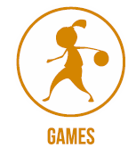
 | Jumping for Height |  | Skipping |  | Catching
Term  3 | April | May |  | June |  | Subject to pool timetabling per class
 | Kicking | Jumping for Distance |  | Throwing |  | Hopping

Discretionary curriculum time ‘affords the teacher and the school the flexibility to accommodate different school needs and circumstances and to provide for the differing aptitudes and abilities of the children it serves. It can be allocated, at the teacher’s and at the school’s discretion, to any of the six curriculum areas’ – PE being one of the curricular areas. This school will use its discretionary time for the 6 weeks of the pool-based activities undertaken to facilitate the Aquatics programme in the school - in order to cover the time travelling to and from the pool.
Active School

We are currently in the process of applying to become recognised as an Active School. The Active School Flag (ASF) is a Department of Education and Skills initiative supported by Healthy Ireland. The ASF is awarded to schools that strive to achieve a physically educated and physically active school community. The process aims to get more schools, more active, more often. In order to achieve the ASF, we began the process by self-evaluating our current provision across three areas: Physical Education, Physical Activity and Partnerships.

Each year, Carrigeen NS will facilitate an Active School Week whereby the discretionary curriculum time for the period in question is used to promote physical activity for all children in the school encompassing as many of the strands of the PE curriculum as possible. This will take place in June. In addition to PE we prioritise physical activity throughout the day during Active Schools Week.

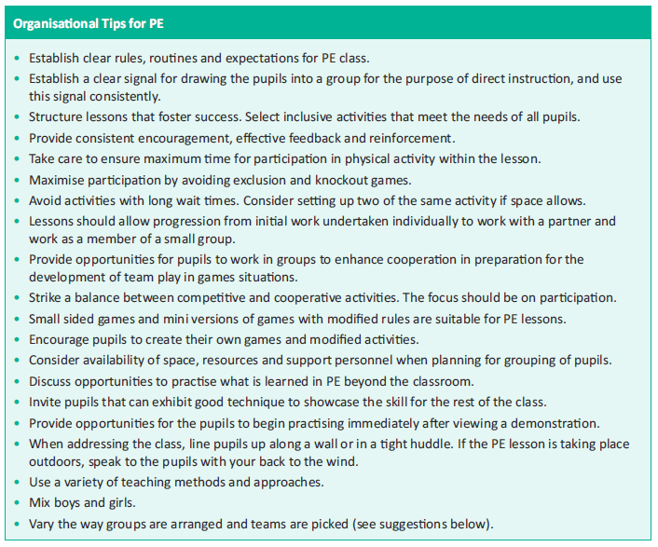

Code of Ethics

(Refer to school’s Child Protection Policy based on the Department of Education and Science guidelines accompanying the ‘Children First’ guidelines.

- If coaches from a local or a national sporting organisation are invited into the school to work with the children as part of their PE class, they will be used to support the class teacher in the implementation of some of the PE curriculum strands in the school. They will not replace the class teacher and ultimate responsibility for the class lies with the class teacher. The class teacher will in turn support the coach on certain occasions when this will lead to maximum benefit for the children in the class.

- Any coaches working in the school context should undergo Garda Vetting and will be expected to adhere to the Code of Ethics of Irish Sport, produced by the Irish Sports Council. ‘Adults interacting with children in sport (referred to as Sports Leaders in this Code) are in a position of trust and influence. They should always ensure that they treat children with integrity and respect and that the self-esteem of children is enhanced. All adult actions in sport should be guided by what is best for the child and carried out in the context of respectful and open relationships. Verbal, physical, emotional or sexual abuse of any kind or threat of such abuse is totally unacceptable within sport, as in society in general.

- If there is a suspected case of child abuse in the class (even if it becomes apparent in the context of a PE class), all teachers will adhere to the Department of Education and Science Child Protection Guidelines to be used with the ‘Children First Guidelines’ (2011) produced for all personnel working with children.

After School Activities

After school activities might be organised by the teachers in the school. All children of relevant age to the activities being offered will be invited to attend. These activities will adhere to the general principles of the P.E. curriculum of the school as follows:
- The importance of enjoyment and play
- Maximum participation by all children
- The development of skills and understanding
- A balance between competitive and non-competitive activities
- A balance between contact and non-contact activities
- Providing opportunities for achievement for each child
- Providing activities equally suitable for boys and girls.
Sports Activities:
Sport and physical activity are highly valued and promoted both at a recreational and competitive level at Carrigeen NS. We strive to nurture the holistic development of the children within our care in a safe, fun, sporting environment. We aim to facilitate and nurture students’ personal and social development, thus enabling them to flourish socially, emotionally and physically. We actively encourage the participation of students from a very young age and promote the inclusion of all students, including those with special educational needs.

At Carrigeen NS, we endeavour to promote sports of every kind with particular emphasis on our native Gaelic games, Hurling, Handball, Camogie and Gaelic Football. A systematic and co-ordinated approach is taken to the organisation of activities and events before school, during lunch time and after school. Teachers voluntarily give their time, energy and enthusiasm to promote and facilitate students’ involvement in these activities.

PE Equipment and ICT (Refer to pp. 104-105 Teacher Guidelines)

- Our school has a detailed inventory of equipment and resources available for PE. This list is compiled by the post holder and is checked and updated at the beginning of each school year.

- It is stored in a room/store in the hall.

- Each teacher has access to the store room and it is the responsibility of each class teacher to ensure that all equipment is returned to the room after each lesson. Any breakages have to be reported to the post holder as soon as possible. The post holder will inspect the room once a month. Each teacher will be given a copy of the equipment list and will be informed of any changes to it throughout the year.

- The Principal and the staff will have the responsibility to purchase the PE equipment for the school and to apply for equipment from different organisations who give free equipment to schools.

- The BOM, on the recommendation of the Principal will sanction a budget for updating of PE equipment annually - subject to funds being available. At present, there is no dedicated PE grant. The Principal will also request additional funds from the Parents Association.

ICT (Refer to p. 101 Teacher Guidelines)

- In order to ensure a PE rich environment, the school will have a dedicated PE/Active School information board where school and local events will be advertised. The use of the school’s digital camera will be vital in recording PE activities. The display of these pictures on the notice board will give an opportunity to children to see themselves and others in action.

- The use of the digital camera as a diagnostic tool for teacher is extremely valuable as children can view their own performances while still involved in a PE lesson. They can make immediate changes to the quality of their movements which in turn will enable them assess themselves in a more meaningful way. For example, this is particularly true when investigating the theme of balance in the gymnastics strand. Use will also be made of a digital video camera from time to time to enable children view their performance of certain activities in the PE classroom. The teachers will initiate discussion of same with the pupils and field any questions the child may have as to how the quality of their performance could be enhanced.

- Microsoft Office, Digital Camera software, Publishing Software will be necessary in the school and most of the software is loaded on the school computers.

- All internet usage follows the strict guidelines laid down by the school in our Internet Usage Policy. This covers the use of appropriate software and the access to safe websites. Teachers will visit websites prior to children being referred to them and much of the websites will be visited by the teacher and shown to the children through a data projector.

- We currently use the following ICT aids to teach PE… (gonoodle.com, Justdance.com, cosmickids.com…etc)

Health and Safety (Refer to schools Health and Safety Policy)

Issues identified as being health and safety issues in a PE context include warm-up at the start of all physical activity, practising in confined spaces, use of equipment, accidents, supervision, activities involving the whole school yard, procedures for dealing with accidents …etc

It is important to acknowledge from the beginning that while the following procedures will eliminate unnecessary hazards they cannot remove all risks due to the physical nature of the subject. When engaging children in PE all members of staff will ensure that the following safety aspects will be taken into consideration

- All children have to wear suitable footwear and clothing during a PE lesson.
- The equipment used will be suitable in size, weight and design to the age, strength and ability of the child and be of good quality and in good repair.
- Children will be taught how to lift and carry all PE equipment safely.
- In all PE lessons, children will warm up and cool down. This develops good practice and the children will return to class relaxed after activity.
- Should an accident occur in the PE lesson we will follow the procedures outlined for other accidents in our Health and Safety policy.
- Running activities will not finish at a wall or pole
- Best practice is safe practice and the teacher should ensure that the children understand that the rules and procedures are there for their safety.
- We will endeavour to have an appropriate surface for the activities in the PE lesson
- Children will not be forced to do activities they are not physically or psychologically ready for.

There will be at least one person on staff with a current First Aid qualification and the BOM will fund the course fees. The First Aid Kit is kept in the staffroom and is restocked regularly with items only recommended by First Aid personnel. A second portable kit is also available when children are participating in PE outside the school grounds. The medical conditions of all children are detailed by their parents/guardians on the school enrolment form. These are then transferred to a central file and any cases teachers need to be vigilant of are also kept in a separate book in the staffroom in order that the teachers have immediate access to information on the conditions and resulting procedures to be followed. Their parents/guardians will be contacted and if necessary, their family doctor as outlined on the aforementioned enrolment form. Detailed leaflets are made available to all staff on specific conditions such as asthma, diabetes and allergic reactions etc.

Individual Teachers’ Planning and Reporting

The whole school plan and the curriculum documents for PE will lay out the structure and format that teachers will follow in addition to the aims and objectives of the primary school curriculum. While these documents are vital for planning, it is important that teachers do not rely on them exclusively as it is necessary to adapt the PE plan to your own class level and experience. It is vital that all teachers plan individually while at the same time ensuring that their class plans co-ordinate and feed into the overall school plan.

Teachers will plan based on the strands as outlined on the yearly timetable in Section 8 and can explore the use of themes in their planning especially in Gymnastics where themes such as balance and travel can provide a great stimulus for lessons (Refer to pp. 34-35 Teacher Guidelines).

The Cuntas Miosúil will be very relevant in reviewing and developing the school plan for the following years. Once the individual cuntas miosúil have been evaluated it should be obvious to the staff which elements of the curriculum were being implemented.

Staff Development

The post holder will take responsibility for monitoring developments in PE - current research, reference books, resource materials and websites dealing with PE. www.pdst.ie and www.irishprimarype.com have definite links to the curriculum and PE in Ireland. The school has a library of relevant resource material which will aid the teachers in their development and implementation of the PE curriculum and we endeavour to build it. An inventory of organisations will be drawn up where free resources will be available.
The post holder will compile a list of suitable websites from where teachers will be able to source material.
Teachers have access to reference books, resource materials, current research and web-sites dealing with PE. Courses in PE offered by Kilkenny and Waterford Education Centres are brought to the attention of the staff. Staff are supported and encouraged to undertake further training and accreditation where possible.

Parental Involvement

We will ask all parents to support their children to participate in all strands of the PE curriculum. We will ask parents with recognised areas of expertise in the area of PE and/or Sport to support us in our efforts if their talents will be of benefit. We will outline the benefits of the PE curriculum at an information session for parents and stress the difference between PE and sport and encourage them to become involved in our Active School Week or any initiative we will organise. We will encourage sporting endeavour at all times. In order to implement swimming lessons and to partake in school sport, we may need the assistance of parents in a supervisory capacity, transporting children to sporting events and helping with supervision. As with any curricular plan in the school, parents can inspect it on the school website.

Community Links

We are very much aware of the school’s role in the community and we are also conscious of the fact that the expertise of people in the community is an invaluable resource to any school.

The school maintains a close working relationship with local sports clubs and partnerships and recognises the importance of these clubs in the community. The school works closely with Mooncoin and Carrigeen GAA, along with Mooncoin badminton and soccer clubs.

- We will also make reference to famous sports people from our community and invite suitable people into the school to talk to the children as long as the content is in keeping with the sentiments of the curriculum. If a local team or individual has had a notable victory, they will be invited in to the school to share the victory with the local children.
- The community has also been involved in fundraising for PE equipment for the school.

Review

Roles and Responsibilities
The P.E post holder will co-ordinate the progress of the plan, encourage and accept feedback on its implementation and report to staff on findings. The plan be monitored and evaluated every May as the school year nears an end and we can reflect meaningfully on how well the PE programme has been taught and received in the school. The following will be consulted in appraising the PE plan

- Teachers
- Pupils
- Parents
- Post holders
- BOM/DES Inspectorate

Ratification and Communication

The PE plan has to ratified by the Board of Management and parents can inspect the plan in the school office.

Signed_____________________________ Date __________________________________

Page 10, PE Curriculum, 1999
Introduction to the Primary School Curriculum, page 68

