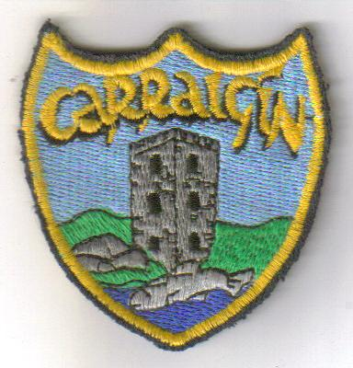

Healthy Lunches Policy

Some Points to Remember!

Healthy Packed Lunches Guide:
Sandwiches:(preferably on wholemeal bread or rolls or a mixture of wholemeal and white) Use a variety of sandwich fillings e.g. cheese, lean meat, chicken, turkey, sardines, tuna, mackerel, salmon, egg, peanut butter.
Savouries: Slices of pizza, quiche, crackers and cheese, mixed salad in a container. Make salads interesting by including extras such as tomato, cucumber, lettuce, onion, coleslaw, pickles, beetroot, gherkins etc. Include a grated raw carrot, sticks of celery or a whole tomato for a healthy nibble.
Snacks: All kinds of fresh fruit e.g. apple, orange, mandarins, banana, pear peach, plum, grapes. Dried fruit may also be included e.g. sultanas, raisins, dates, yogurt, popcorn, scones, brack, fruit cake, digestive biscuits.
Drinks: Milk/water are the best drinks for growing children. Unsweetened fruit juices that contain no additives are all healthy options.
On Friday, children are allowed a treat in their lunch box. E.g. bun, muffin,
Please note that sweets, chewing gum, chocolate bars,crisps and isotonic/fizzy drinks are not allowed in school(before school) or as part of a child’s lunch on any day. These items do not form part of a healthy lunch.
Peanuts are also not allowed in school.
Remember: A Healthy Child Is a Happy Child!!

This policy was ratified by the Board of Management of Carrigeen NS

